Vật dụng trong phòng thí nghiệm:

(Tube là ống, rod là que)

------

Test tube

Test tube holder

Test tube rack

Rubber

Pasteur pipette (Dropping pipette)

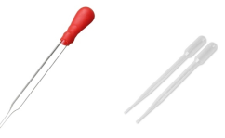

Graduated pipette (Volumetric pipette)

Pipette

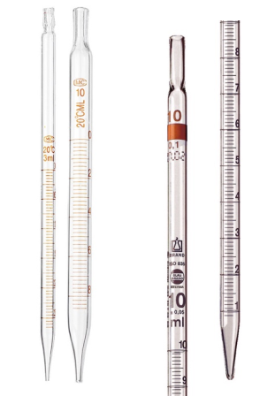

A **glass stirring rod**, **glass rod**, **stirring rod** or **stir rod** is a piece of [laboratory](https://en.wikipedia.org/wiki/Laboratory) equipment used to mix chemicals.

Bunsen burner

**Alcohol burner**

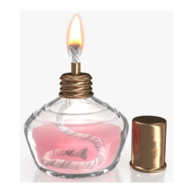

Loop

Looped wire

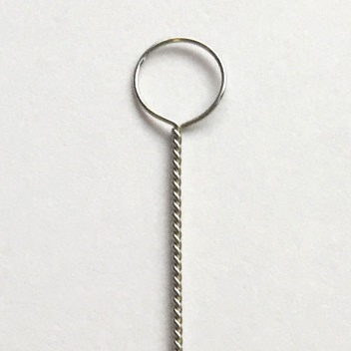

Erlenmeyer Flask

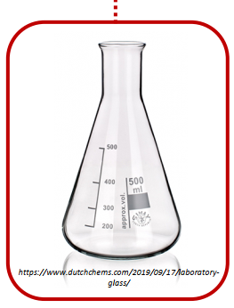

Volumetric flask

Cylinder

Beaker

Burette

Duran bottle

Dropper bottle

